Scenario #1(i3 Origination)

1 Scenario Description 1

1.1 Test Bench retool 2

2 Prerequisites 2

2.1 Location(s) & Layers 2

2.1.1 ECRF Layers 3

2.1.2 IMS Locations used 3

2.2.1 Static County ECRF Mapping & LDB/LNG Interworking 4

2.2.1.1 Device Based 4

2.2.2 ECRF County Layer to URI mappings. 4

2.3 Configure for loggers & recorders 4

3 Detailed Steps 5

3.1 SIP 5

# 1 Scenario Description

Standard i3 Call. A caller from a Wireless or Landline phone has dialed or pressed emergency to initial a request for action to the local public safety system.

This call will come from the OSP/LNG into the SBC/BCF of IIT. IIT will point their association with the current OSP to point to the iBCF position on the test bench. The iBCF will forward the call to the appropriate ESRP. The ESRP will use the provided geolocation information, received by-value or by-reference, to query the configured ECRF w/URN of sos using the findService method. The returned URI will route the call to the appropriate Emergency Queue for the location provided. This Queue will forward to the appropriate URI pointing to the eBCF and, subsequently the CHE used by the answering agency.

The Called Agent will verify the proper connectivity for the media used, e.g. A short exchange, and hang up the call when they are satisfied.

During this call, the SIP interfaces are exercised between BCFs, ESRP, and CHFEs.

Held and Lost are exercised between ESRP, ECRF, and CHFE.

EIDO is exercised between CHE and CAD.

## 1.1 Test Bench retool

1. OSPs -
   1. OSP1 – OSP1 will point ECRF to one of their two toolings.
      1. IIT will repoint their BCF to the iBCF in the test.
   2. OSP1 -
      1. IIT will repoint their BCF to the iBCF in the test.
2. iBCFs point to ESRP in the test.
3. Between subsequent test runs the lab is retooled at the ECRF in the test by changing the URI for which the appropriate location routes.
4. ESRP Queue points to eBCF/CHFE in the test.

# 2 Prerequisites

1. SBCs and iBCFs are pointed to the appropriate BCFs/ESRPs in the test.
2. ECRF(s) in test have been pre-provisioned with the proper URIs pointing to the queue used for the CHE in test.
3. CAD systems have pre-subscribed to CHE in test.
4. ESRPs have the required Queues and URIs pointed to the appropriate eBCFs.
5. eBCF is pointed to the appropriate CHE in test.

## 2.1 Location(s) & Layers

The following location information will be used to route calls to the appropriate PSAP for each test run. Calls made from IL addresses will force the ECRF in the test to either redirect or recurse to the FG. FG will either forward or redirect to the ecrf.il.ng911test.iit.edu for the PSAP URI pointed to by the location.

See the ICE 10 Location spreadsheet for details, currently at ***[Redated Link, see local file package]***

### 2.1.1 ECRF Layers

We will have two regions. The first region will be used to exercise all ECRF vendors during the event. These ECRFs are authoritative for KS, WA, NJ, and TX. These ECRFs will resolve locations provided by the OSPs to specific CHEs using the mapping/retooling(s) detailed in later sections of this document. These retooling is used to point the different locations to each OSP, routing to different CHEs during the tests.

The second region will be used to exercise the Forest Guide. When a request for IL location is received by an ECRF provisioned with Region 1 boundaries, they will not have coverage for IL. They will need to redirect or recurse to the FG. The FG will either return a location or redirect to the ECRF for region #2.

1. **Regional #1 ECRFs** 
   1. **States** - Combination of KS, WA, NJ, and TX only
2. **Regional #2 ECRF** -
   1. **States** - IL
3. **Forest Guide ECRF** -

### 2.1.2 IMS Locations used

* [Redacted]
  + **C1_OSP1_WA** -

A2: KING

1759 135TH PL NE

BELLEVUE WA 98005

* + **C2_OSP1_KS** -

A2: JOHNSON

6220 SPRINT PKWY

OVERLAND PARK KS 66251

* [Redacted]
  + **C1_OSP2_NJ** -   
    A2: SOMERSET  
    180 WASHINGTON VALLEY RD  
    BEDMINSTER NJ 07921
  + **C2_OSP2_TX** -  
    A2: TARRANT  
    1600 SOLANA BLVD  
    WESTLAKE TX 76262
  + **C3_OSP2_TX** -A2: DALLAS  
    700 HIDDEN RIDGE  
    IRVING TX 75038

### 2.2.1 Static County ECRF Mapping & LDB/LNG Interworking

We will assign static civic locations to Device Identifiers using tel: and sip schema URIs in each vendor’s LIS for interworking with Held.

#### 2.2.1.1 Device Based

Using RFC-6155 Device Identifier tel: URIs that mimic an ESQK/ANI are used.

The following location mappings are to be made in all ECRFs and LISs.

**Note** - Depending on the vendor’s solution an equivalent model may be used such as a pattern URL for Held.

***[Redacted due to Confidentiality Code of Conduct]***

### 2.2.2 ECRF County Layer to URI mappings.

Each ECRF vendor will be assigned an authoritative boundary set. They will configure this in their ECRF and send all other out of area queries to the FG.

**Note** - See ECRF and FG Location Guide for ECRF County Mapping tooling used throughout the event.

## 2.3 Configure for loggers & recorders

All FE Vendors will point their FE(s) to the available logger/recorders.

***[Redacted due to Confidentiality Code of Conduct]***

# 3 Detailed Steps

## 3.1 SIP

1. INVITE(1) from OSP(BCF) to NGCS(iBCF)
2. 100 Trying from NGCS(iBCF) to OSP(BCF)
3. INVITE(2) from iBCF to ESRP
4. 100 Trying from ESRP to iBCF
5. NGCS(ESRP) queries OSP(LIS) for “emergencyRouting” using Held
6. OSP(LIS) returns PIDF-Lo to NGCS(ESRP) in Held Response
7. ESRP queriesECRF using LoST’s findService and urn:service:sos.
8. ECRF returns a findServiceResponse with queue URI to ESRP.
9. INVITE(3) to eBCF from ESRP
10. 100 Trying from eBCF to(ESRP)
11. INVITE(4) from NGCS(eBCF) to Call Handling(CHE)
    1. If there is an is-focus tag the CHE then
       1. SUBSCRIBE to Conference Event Package from CHE to Contact in INVITE(4).
12. 100 Trying from Call Handling(CHE) to NGCS(eBCF)
13. 18X from Call Handling(CHE) to NGCS(eBCF)
14. 18X from NGCS(eBCF) to ESRP
15. 18X from ESRP to NGCS(iBCF)
16. 18x from NGCS(iBCF) to OSP(BCF)
17. CHE queries OSP(LIS) for “emergencyDispatch” using Held
18. OSP(LIS) returns PIDF-Lo to Call Handling(CHE) in Held Response
19. Eventually, the agent answers and CHE sends 200 OK(4) to NGCS(eBCF)
20. 200 OK(3) from NGCS(eBCF) to ESRP
21. 200 OK(2) from ESRP to NGCS(iBCF)
22. 200 OK(1) from NGCS(iBCF) to OSP(BCF)
23. ACK…

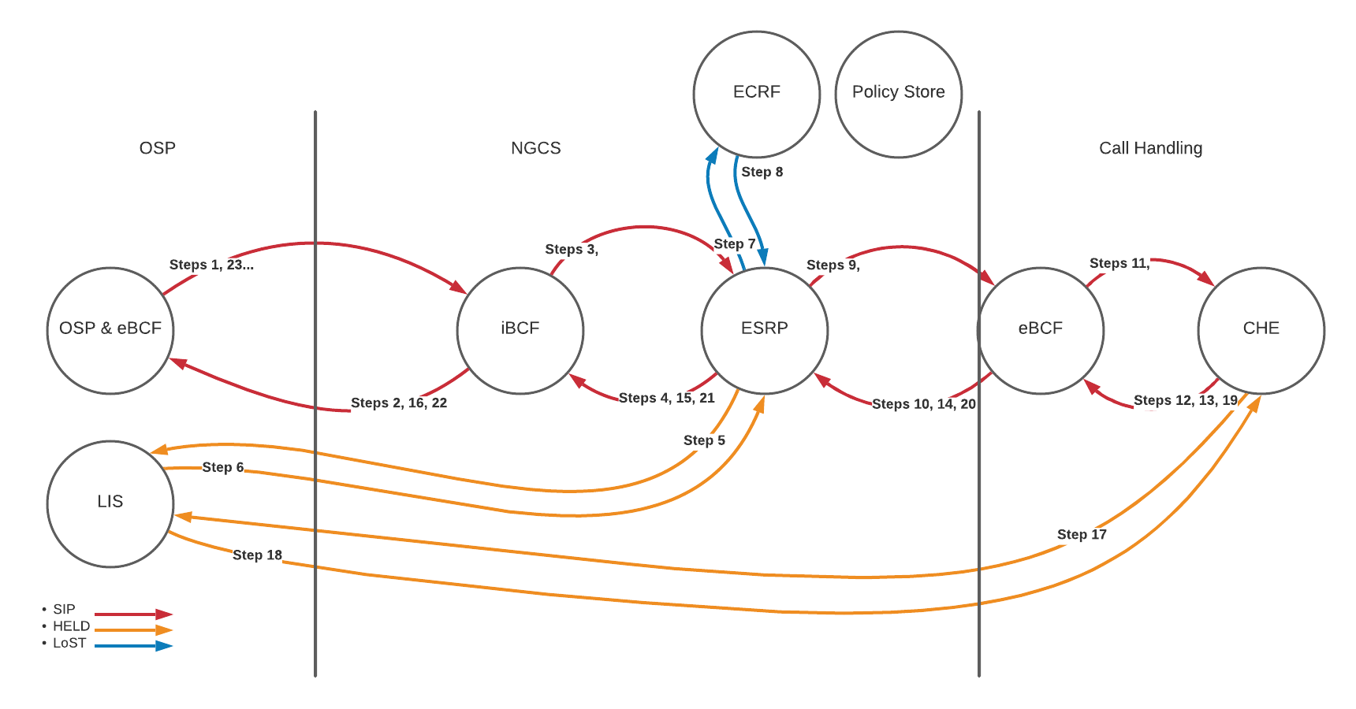

TODOs: Insert logging and those steps, pointing out the events that must be logged. Insert SUBSCRIBE/NOTIFY steps if needed. Policy Store steps where needed.

***[Major Sections Redacted due to Confidentiality Code of Conduct]***